|  |
| --- |
| **New standards: Lansweeper scanning server** |

1 Intro 2

2 Prerequisites 2

3 Lansweeper scanning server installation 3

4 Configure central management 9

5 Configure Altiris Notification Server 15

# Intro

This manual is focused on the deployment of a Lansweeper scanning server on the new standards of JDN.

# Prerequisites

An active VPN connection

Firewall policies should be active

ADMIN-TRUST MONITOR > VPN Lansweeper.db.jandenul.com PORT 1433

ADMIN-TRUST MONITOR > SURVEY, CREW-LAN, CREW-DIA, MACHINE PORTS for Lansweeper

SURVEY, CREW-LAN, CREW-DIA, MACHINE > MONITOR PORT 9524

DNS Alias MONITOR for XX-MONITOR01 exists

# Lansweeper scanning server installation

1. Copy the lansweepersetup.exe from \\jdn-file01\Ict_New_Standard_Sites_Vessels\Software\Current\Lansweeper to the XX-MONITOR01 server of the setup
2. Start the installation and choose “Next”

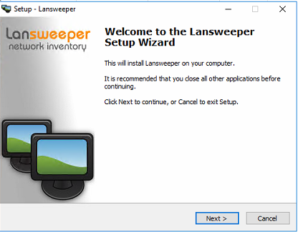

1. Choose “I agree”

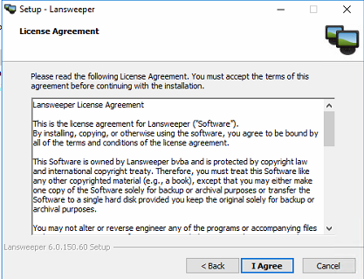

1. Make sure only the following checkmarks are selected

Advanced install

└ Database Type

└ SQL Server

└ New Lansweeper Service

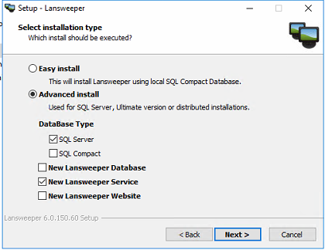

1. Fill in the following information in the fields

Server name: *Lansweeper.db.jandenul.com*

Authentication: *SQL Server Authentication*

User name: *srv_ves_lansweep*

Password: *<see RDM>*

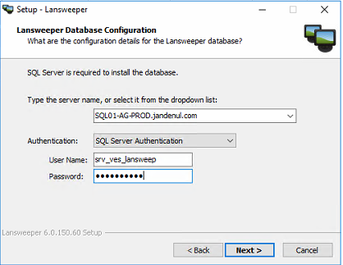

1. Choose “No”

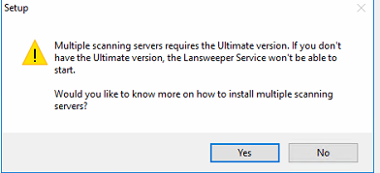

1. Choose “Install”

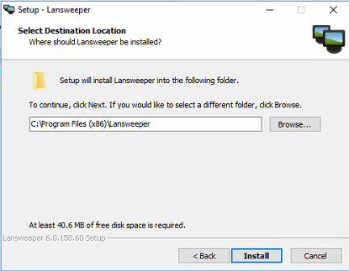

1. Wait for it

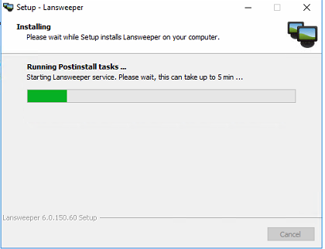

1. Check “Skip Lansweeper ....” and choose “Finish”

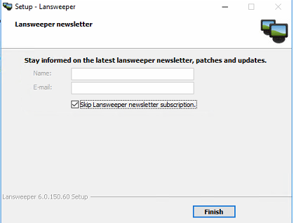

1. Close the webpage

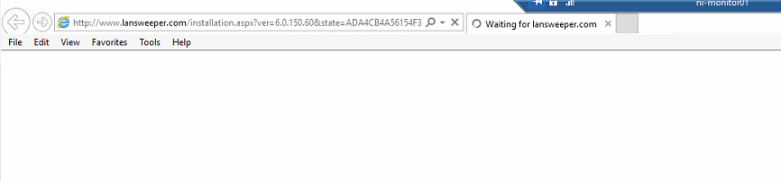

1. Go to C:\Program Files (x86)\Lansweeper\Tools\ConfigEditor.exe and launch the executable
2. Choose “Ok”

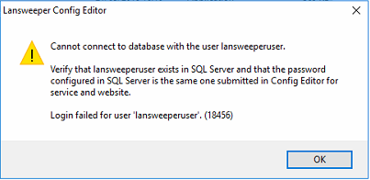

1. Wait for it

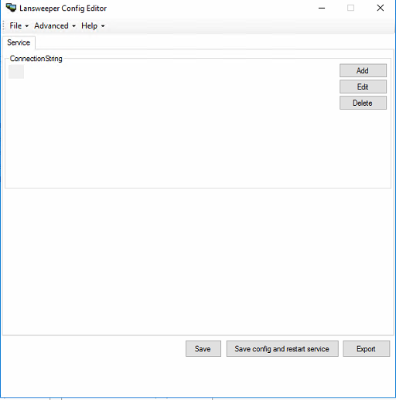

1. Choose “User ID” and click “Edit”, change the user name to “srv_ves_lansweep”

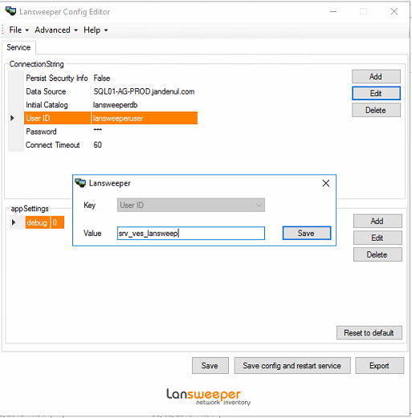

1. Choose “Password” and click “Edit”, insert the password for srv_ves_lansweep

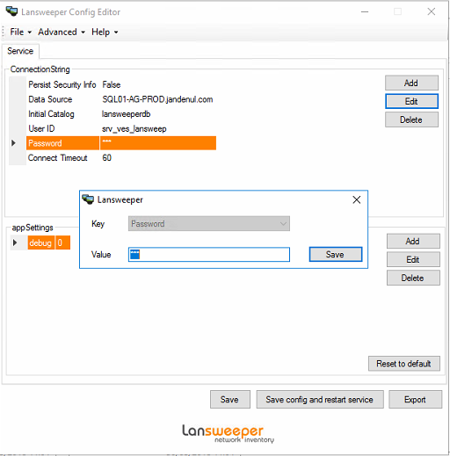

1. Save the config and restart the lansweeper service

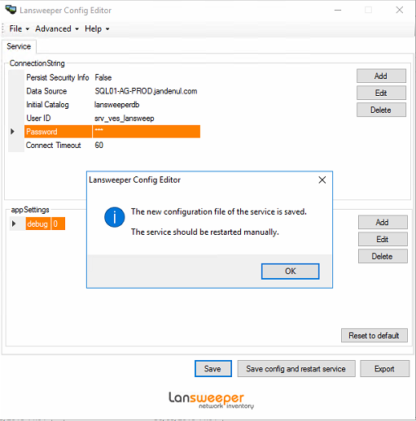

1. Copy \\jdn-file01\Ict_New_Standard_Sites_Vessels\Software\Current\Lansweeper\encryption.txt > C:\program files (x86)\lansweeper\key
2. Restart the Lansweeper service

# Configure central management

1. Open the internet browser and connect to <http://jdn-lansweep01>
2. Choose “Scanning” > “Scanning targets” > XX-MONITOR01

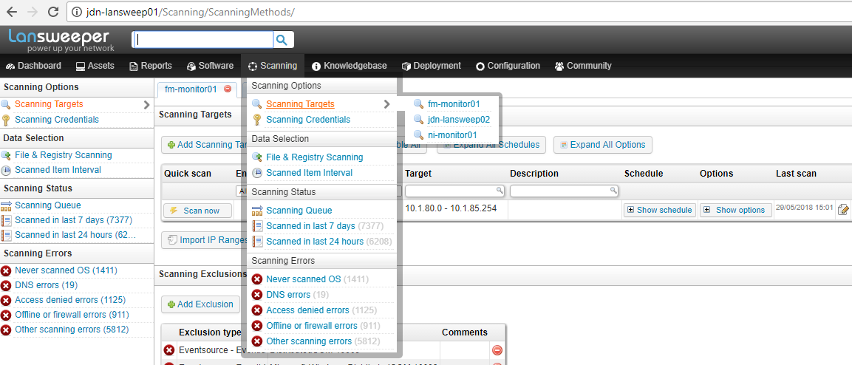

1. Choose “Add scanning target”

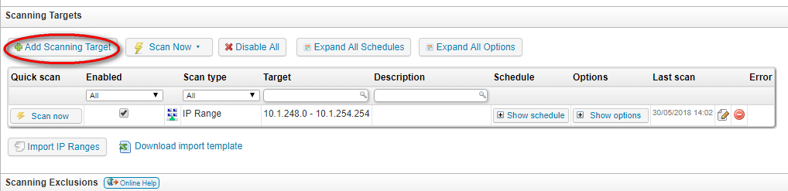

1. Choose “IP Range” (1), insert ip range (2)(3) and click “Ok”

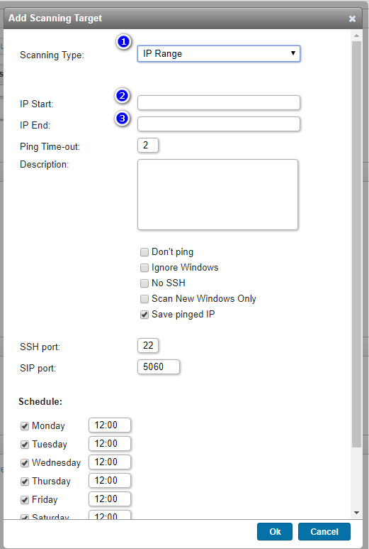

1. Choose “Add preferred domain controller”

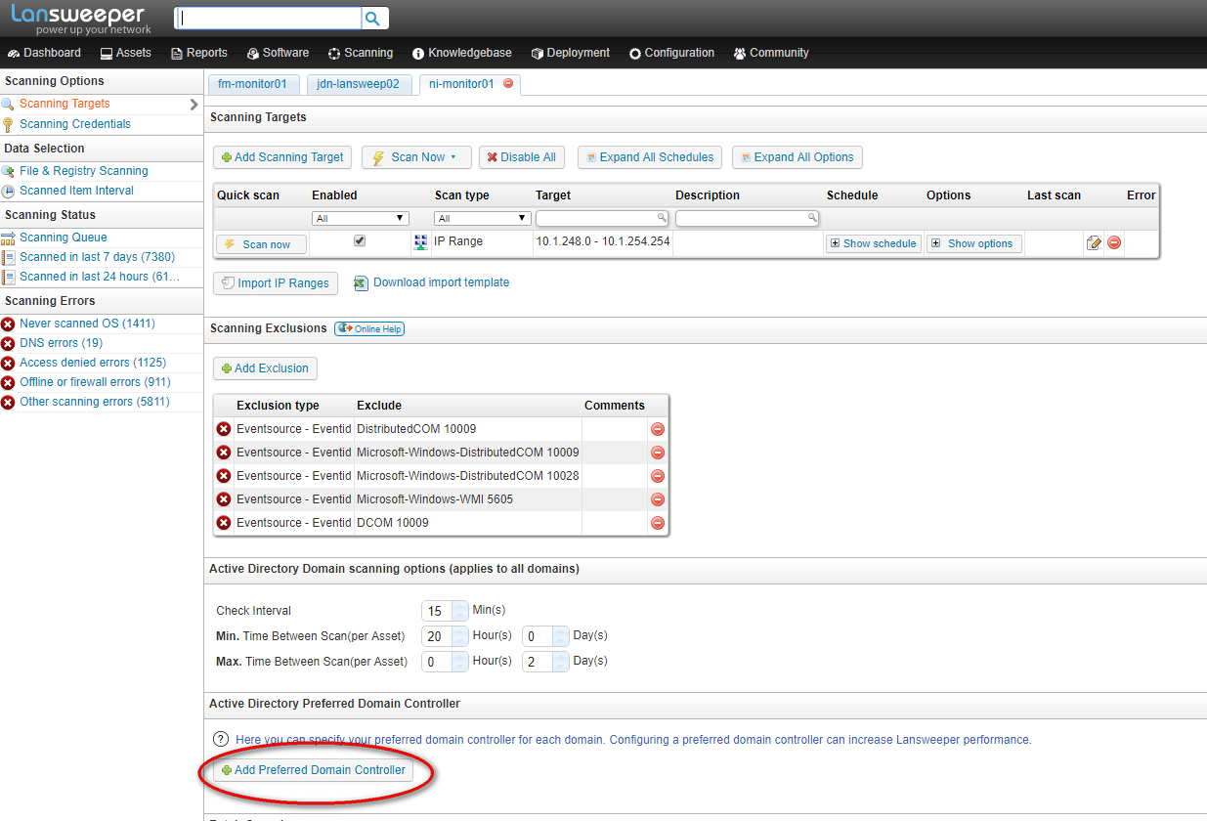

1. Fill in the necessary information

DC DNS name: *XX-DC01.XX.SITUS*

Domain Netbios: *XX-SITUS*

Ex.

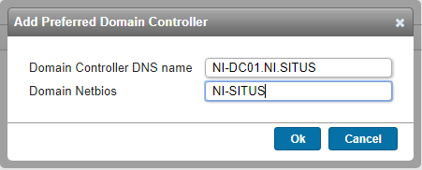

1. Adjust scanning server configuration

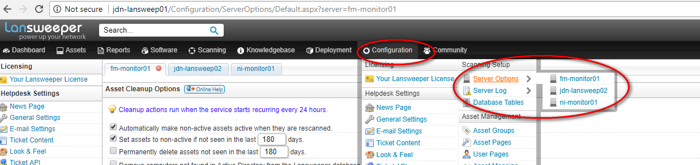

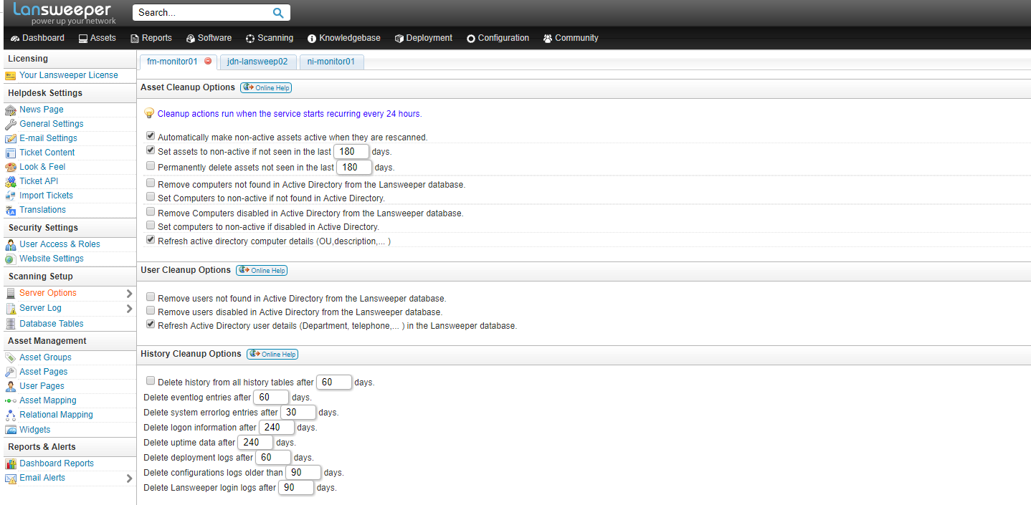

1. Disable scanning target on JDN-LANSWEEP01

Go to “Scanning” > “Scanning Targets” > “JDN-LANSWEEP01”

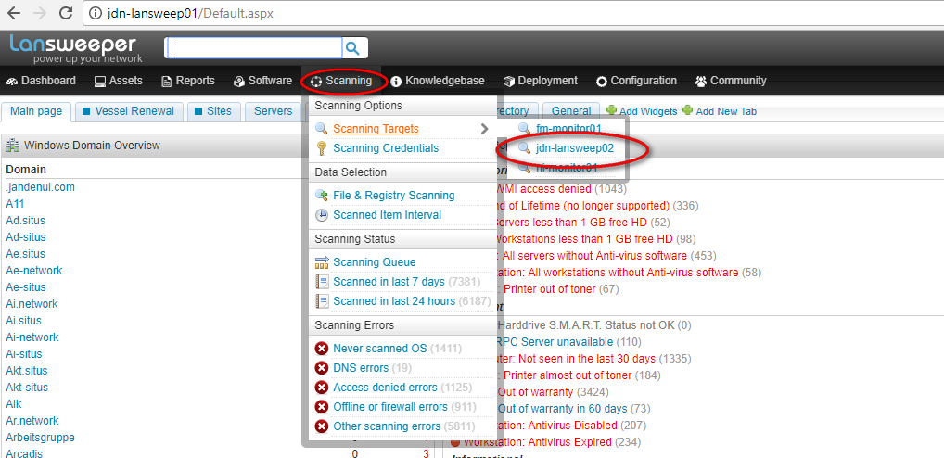

1. Uncheck the “Enabled” check mark next to the range of the setup

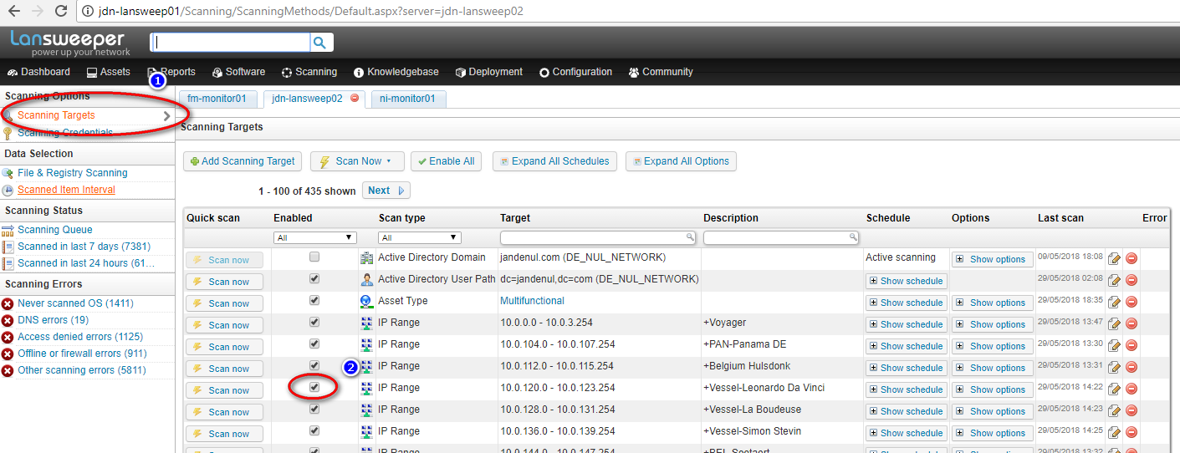

1. Configure scanning credentials
2. Click “Scanning”
3. Click “Scanning Credentials”
4. Click “Add new Credential”

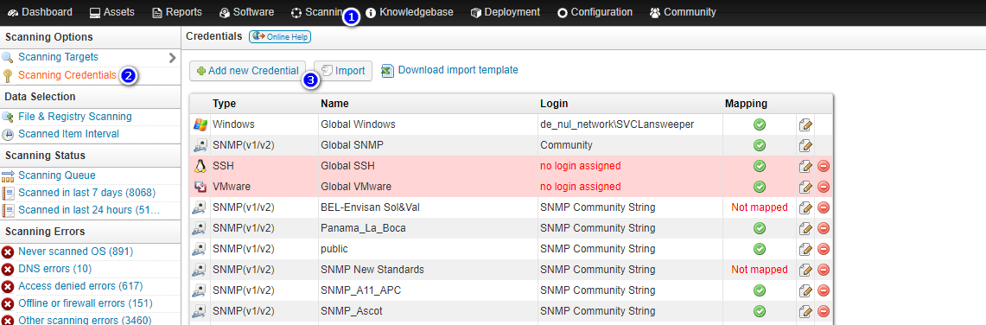

1. User “Srv_Monitor” account

Name: Vessel - New Standard - XX - SRV_MONITOR

Login: XX -SITUS\srv_monitor

Password: <see RDM>

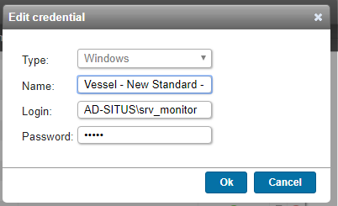

1. Map credentials
2. Select ip range

Click “Credential”

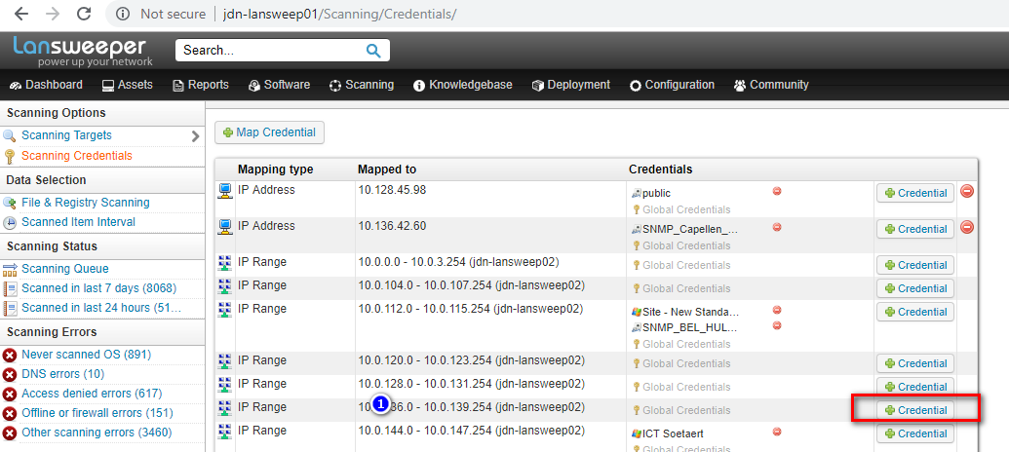

1. Select the correct credentials and click “Add”

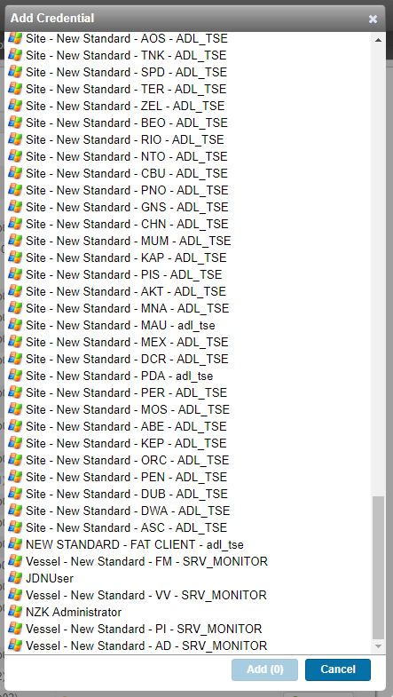

1. Adjust scan server

Go to the asset -> click “Edit asset”

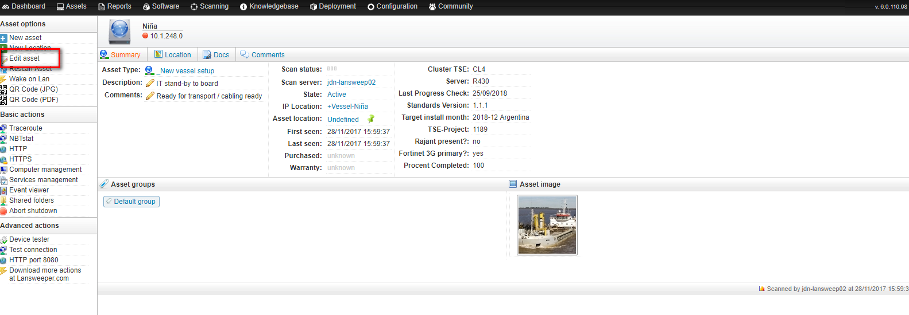

Select the correct scanning server

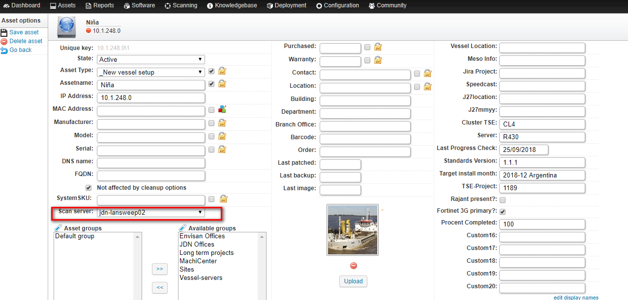

# Configure Altiris Notification Server

1. Ask SE to create a ip range filter in NS, this will be used to scan the fat clients

Ex.



1. Ask SE to adjust the following target and add the ip range filter

